From: https://davidstockmanscontracorner.com/the-time-time-didnt-stand-still-part-1/

The Time Time Didn't Stand Still, Part 1
By David Stockman. Posted On Friday, May 17th, 2019
From the antics of the robo-machines and day traders you would think the economic gods have ordered time to stand still--or at least the cyclical variant of it. Within days we will be in the longest business expansion in American history---meaning that the calendar itself has become a huge risk factor.
Yet the machines pay no heed and keep buying the dip. So doing, they are paying a top-tick PE multiple at 21.5X the LTM reported earnings of the S&P 500 at the tippy-top of the business cycle, implying that there is no end in sight to the octogenarian expansion underway.
The extreme folly of ignoring the cyclical clock, however, lies in the fact that this 118 month business expansion has not been a benign one, wherein the passage of time has been of no moment and where both main street and Wall Street have rolled forward from strength-to-strength.
To the contrary, the last 118 months of positive albeit tepid "growth" since June 2009 have been accompanied by the most dangerous and corrosive eruption of debt, speculation, rent-seeking and re-allocation of wealth to the upper rungs of the economic ladder ever imagined. The body economic, therefore, is riddled with imbalances and unsustainable excesses that have accumulated with the passage of time and have become ever more threatening as they metastasize.
Stated differently, this cycle isn't some kind of economic Methuselah heading for the cyclical equivalent of biblical old age at 969 years. And most especially, it does not comport with the assurance of Keynesian economists that business cycles never die of old age.
Indeed, the latter is surely a case of the pot calling the kettle black. That is, central bankers and their Wall Street cult-followers have even taken to claiming that business cycles end mainly due to monetary policy mistakes (true), but the science of monetary management has now become so advanced and perfected that no such catalyst for recession can be seen anywhere on the horizon (preposterous).
The truth of the matter, of course, is that egregious monetary policy mistakes have already been made. That's because the cause of a crack-up boom does not lie in the belated and futile efforts of central bankers to tighten at the very end of a cycle, but in the years of asset price falsification and massive, artificial credit and liquidity injections that encourage unsustainable leverage, speculation and malinvestment.
Indeed, the same time distance (118 months) in the last bar (orange) of the chart below represents a far more dangerous and unstable old age than the equally long 1961-1969 cycle (105 months) and the all-time record 1991-2001 cycle (119 months).
In a word, under the influence of the Fed's massive balance sheet expansion over the last 10 years, the financial markets have functioned as a devil's workshop, confecting every manner of speculative excess known to both carbon-based and silicon-based traders. The trillions borrowed by corporate America to buyback their own stock is only the most obvious manifestation.
But when it comes to unsustainable excess, the starting point and catalyst has been the leap off the deep-end by the monetary and fiscal authorities. In effect, they have fostered a massive financial accident waiting to happen.
At the peak of the 2000 cycle, for instance, the Federal budget generated a $235 billion surplus and the Fed's balance sheet also expanded by about $40 billion in the normal course of operations. This meant, in turn, that the combined effect of the fiscal and monetary authorities was to inject $275 billion or 2.7% of GDP into the bond pits.
That obviously alleviated top-of-cycle pressure on the fixed income markets, thereby militating against rising rates and crowding out of private investment. Even then, the cycle rolled over into recession in March 2001.
By contrast, during FY 2019, the US treasury will borrow about $1.2 trillion (including off-budget programs) and the Fed will have drained $600 billion under QT--even if it does suspend its balance sheet shrinkage efforts at the end of the current fiscal year.
In any event, unlike the tailwinds at the peak of the 1991-2001 cycle, this time the US treasury and central bank combed will be draining $1.8 trillion from the bond pits---a figure that represents just under 9% of GDP.
Needless to say, when you drain 9% of GDP from the fixed income markets, supply and demand clear at a higher price point.
Yet the US economy is burdened with so much public and private debt (see charts below) that it has virtually no capacity to absorb the crowding-out effect implicit in current Washington policy.
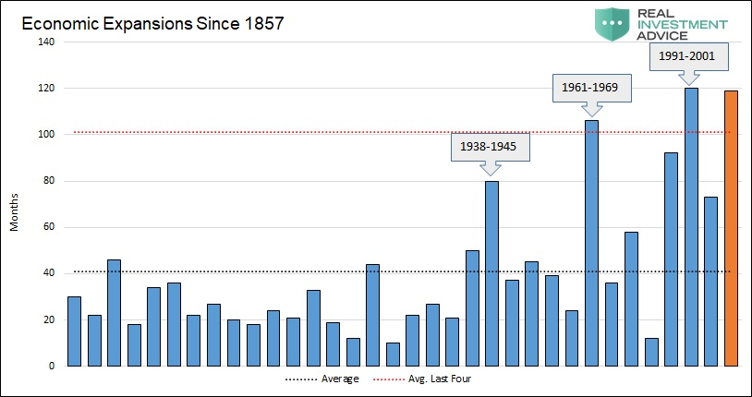
The favorite Wall Street riposte to the cycle age risk is an even more perverse argument than what is in effect the Great Moderation 2.0 conceit of present-day central bankers (version 1.0 was given by Bernanke when on the eve of the worst recession since the 1930s, he said central bankers had essentially abolished the business cycle).
To wit, the argument amounts to "weaker for longer". That is, at the same point in elapsed duration as the present, the 1960s expansion cycle had generated a 52% gain in real GDP and the 1990s expansion had generated nearly a 42% gain.
By contrast, this time the gain is still less than 20% from the pre-crisis peak. That is, not only has there been no equal and opposite rebound to the deep recession of 2008-2009 as per traditional Keynesian theory, but in the years since then the US economy has oscillated at tepid 2% +/- annualized gains.
So doing, it thereby insured that in 118 months of so-called recovery, the US economy has gained less than half of the real GDP growth (light blue line) that had been achieved during the two previous long expansion cycles of the post-war period.
Needless to say, the implicit argument that the expansion will last twice as long because it's been half as strong amounts to paint-by-numbers idiocy.
There are deep structural reasons why the recovery has been so weak. And rather than vanishing because the Donald keeps boasting about the strongest economy ever, they are actually the economic swords of Damocles hanging over an aging business expansion that threaten to trigger the next rendezvous with recession and financial crisis.
Stunning Rebuke: Record Money Pumping, Weakest Recovery Ever
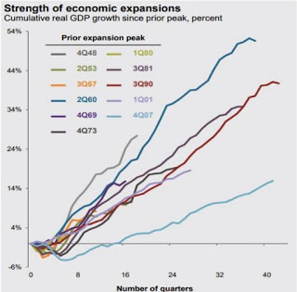
There can be little doubt that the last 118 months have hosted a field day of devil's workshops on both Wall Street and main street. That's because you do not more than quadruple the Fed's balance sheet in barely four years without setting speculative forces in motion that do not stop until the resulting bubbles finally reach their asymptote and crash.
One of these deformations, of course, is excess liquidity itself. At the peak of the Fed's balance sheet expansion which reached $4.5 trillion in late 2014, there was actually $2.6 trillion of excess bank reserves sitting on the Fed's balance sheets as liabilities to US banking system.
But these so-called excess reserves---which at that point represented approximately 20X the actual required reserves of the banking system under current law and regulation---were not financial ciphers.
That is, they were not needed to backstop loan-to-deposit ratios in the banking system, but the entire excess reserve was hypothecated---especially by the big Wall Street oriented banks---and used to support leveraged trading operations in the fixed income and risk asset markets.
The Fed's Post-Crisis Money Printing Spree Was Off The Charts
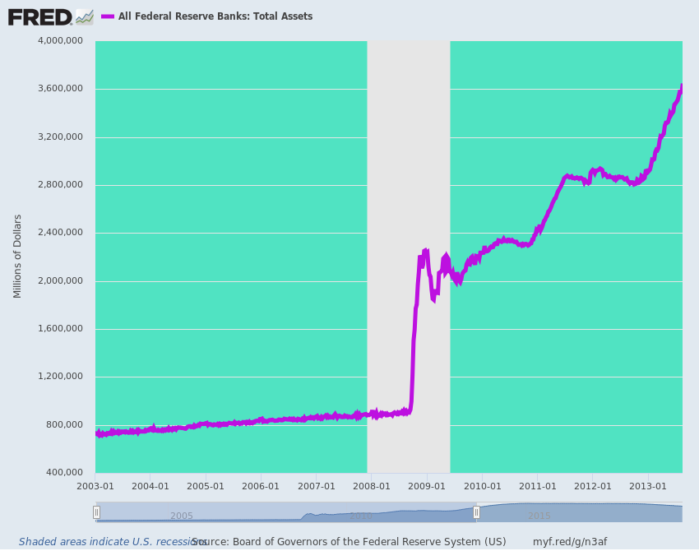
Now, of course, the Fed has finally reached the point where even its Keynesian monetary central planners realized that normalization was necessary if the Fed was to replenish its dry powder for the next economic downturn and financial crisis.
Still, even with shrinkage of its humongous balance sheet to about $3.95 trillion at present and a tepid normalization of the federal funds rate to just above the inflation rate, thereby setting the money market in positive real terms for the first time since April 2008, the level of excess reserves in the banking system remains in excess of $1.6 trillion.
While all of these excess reserves remain high-powered juice for speculation in the canyons of Wall Street, the point is that the Fed-generated excess liquidity that fueled the boom in risk asset prices has peaked and is reversing direction.
And that means, in turn, that the speculative bubbles generated during the peak of the Fed's liquidity pumping operations rest on an ever more precarious foundation.
But Even The Keynesian Monetary Central Planners Finally Recognized That Normalization Was Necessary
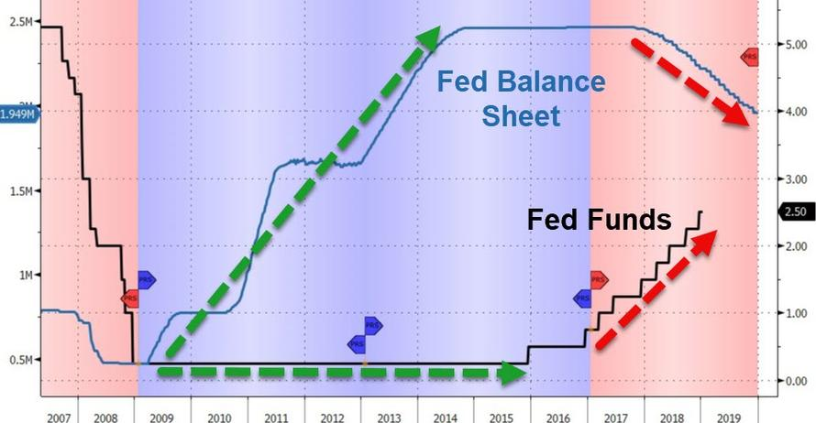
Needless to say, in the context of shrinking excess liquidity and rising interest rates, the total debt burden crushing the main street economy---public and private combined---will become ever more onerous. That's because notwithstanding the alleged wake-up call presented by the Great Financial Crisis (GFC) with respect to America's soaring indebtedness, it's only been off-to-the-races since the dark economic winter of 2008-2009.
In fact, total debt---business, household, government and finance---is up by nearly $21 trillionor 40% from $51 trillion to $72 trillion. And that represents $3.75 of new debt for each dollar of added nominal GDP over the last 12 years.
The question recurs, therefore, as to whether the US economy can keep piling on debt at a 3.75: 1 ratio and not incur growing risks of instability and structural barriers to growth as the business cycle reaches its waning months.
Stated differently, if you think an 118 month old business expansion is not inherently at risk, you also have to believe that 12 years of attempting to borrow our way to prosperity has not created hidden risks that make the pricing of equities to perfection an even more foolish undertaking today than was the case in October 2007.
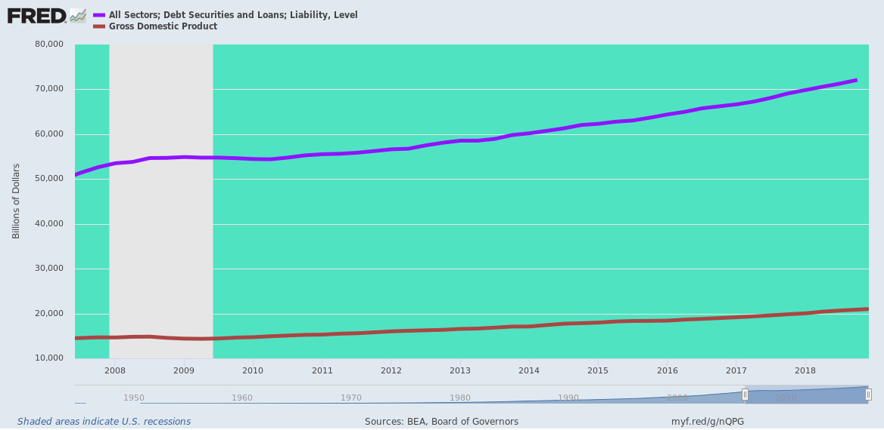
To take one sub-component, consider what has happened to auto debt during the past 10 years in the devil's workshop. As shown in the chart below, the modest de-leveraging of the auto fleet which occurred during 2009-2010 in the aftermath of the GFC has been reversed long ago.
Total auto loans and leases now stand at nearly $1.3 trillion or nearly 65% above the pre-crisis peak. And more importantly, the loans are larger and the terms are longer than ever before.
That's implicit in the far lower growth of the total number of auto loans outstanding (red line), which have risen by only 25% from the pre-crisis peak.

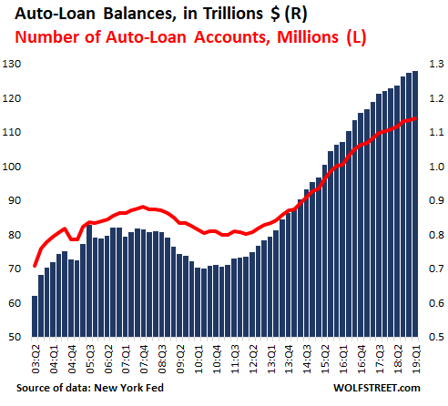
Not surprisingly, "larger for longer" auto loans represented just another form of risk build-up during the long run of the devil's workshop. Most assuredly, underwriting standards loosened considerably and future risks of default and loan losses were being accumulated.
Accordingly, auto loan delinquencies have been surging. In fact, they have now reached the highest level since Q4 2010 and stand at merely 58 basis points below the peak during the Great Recession in Q4 2010 (5.27%):
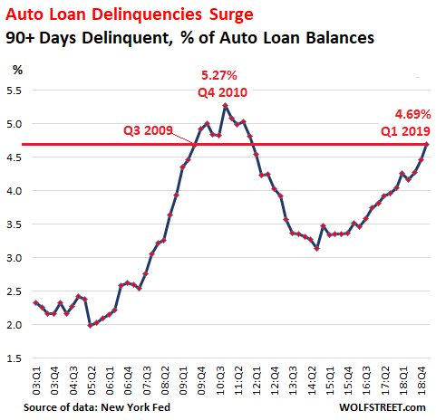
But there's more. As the total level of auto loans ballooned, the embedded risk of loss has soared. Compared to about $35 billion of delinquent auto loans at the peak in 2010, current loans at risk total more than amounts to $60 billion and are rising rapidly.
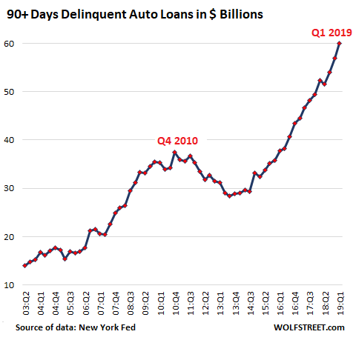
Needless to say, these examples only scratch the surface. In Part 2, we will further explore the huge risks to cyclical old age that were fostered by the Fed's egregious money-pumping during the years since the GFC/

